March 1, 2018
Dear colleague,
Since 2014, the Pre-K for PA’s Executive Leadership Council has played an important role in generating support for expansion of high-quality pre-k among leaders in Harrisburg. Over the past four years, Pennsylvania has increased its investment for early childhood education in the commonwealth by $100 million, creating pre-k opportunities for more than 10,000 thousand 3-and 4-year-olds statewide.
Unfortunately, even at current funding levels 61 percent—or about 106,000 children—lack access to programs like PA Pre-K Counts and Head Start each year.
On behalf of Pre-K for PA, we invite you to join us as members of the campaign’s Executive Leadership Council to demonstrate public support for high-quality pre-k as a crucial priority for Pennsylvania’s economic growth. This executive-level group includes the commonwealth’s top leaders across business, civic, education, law enforcement and even national security sectors in regions across the state.
In joining the statewide Executive Leadership Council, you are endorsing Pre-K for PA’s core principles: By 2022, every at-risk child will have access to a high-quality pre-kindergarten program and middle-income families will more easily afford these services for their children.
Pre-K for PA is setting this goal but not prescribing a specific pathway to increased access. Instead, we have worked to educate Pennsylvania’s policy makers on successful models and policies from other states that can inform the commonwealth’s approach.
Committing to serve on the Pre-K for PA Leadership Council can be as simple as lending your name in Pre-K for PA materials, or get further involved in leveraging your personal networks, meetings, speaking engagements, press events, etc. You will be updated periodically on Pre-K for PA’s progress and encouraged to participate in specific actions. Your level of engagement is entirely up to you.
We hope to count on your support. To sign on or learn more, please visit www.prekforpa.org/executive-leadership-council or contact Pre-K for PA at info@prekforpa.org.
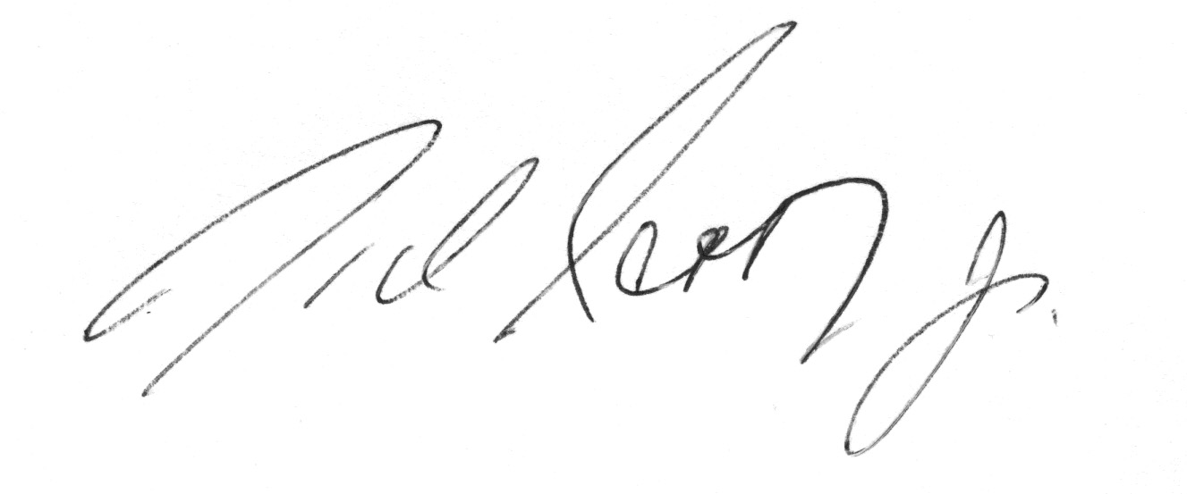
Sincerely,
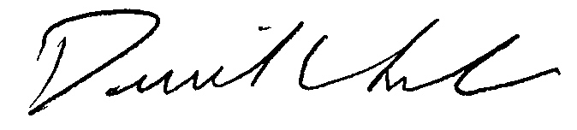

David L. Cohen Nick Scott, Jr.
Comcast Corporation Scott Enterprises

